

**Multimodal Sensory Biofeedback**

**with Virtual Reality System**

Report on

NTU 10-week Industrial Orientation

with Institute for Infocomm Research (I2R)

(29th May 2014 – 26th July 2014)

Submitted by: Oh Su Jin

Matriculation Number: U1022007D

Supervisor: Mr. Aung Aung Phyo Wai

School of Electrical and Electronic Engineering

Contents

Abstract 3

Chapter 1. Introduction 4

1.1 Background 4

1.2 Objectives 4

1.3 Scope 4

Chapter 2. Literature Review 5

2.1 Leap motion 5

2.2 Kinect 6

2.3 AcceleGlove 7

2.4 Existing physiotherapy application 7

Chapter 3. Proposed Solution 8

3.1 iFarm 8

3.2 Overview and Objective of iFarm 8

Chapter 4. iFarm Design and Integration 9

4.1 Application flow 9

4.2 System architecture 10

4.3 Program flow 11

4.4 Java-Unity integration 11

Chapter 6. Approach to finger movement assessment 12

6.1 Data Analysis 12

6.2 Types of Exercise 13

6.3 Difficulty level 13

Chapter 7. Discussion 13

7.1 Summary of tasks done 13

7.2 Future tasks to be done 14

7.3 Problems encountered 14

Chapter 8. Conclusion 15

**Bibliography** 16

Abstract

Technology in modern era is becoming more intuitive and natural. Natural User Interface (NUI) which enables users to experience much easier and intuitive human-computer interaction is therefore increasingly popular and seen as the future of User Interface. Hand gesture interface, in specific, is one of the most actively researched NUI and has great potential to provide holistic human-computer interaction, bringing computer closer to human (NUI: Natural User Interface).

Physiotherapy uses a variety of techniques to help one’s muscles and joints work to their full potential and it is now playing a vital part in repairing patients’ damage by speeding up the healing process and reducing pain and stiffness. However, such prescribed and routined traditional exercises can be boring and lead to poor compliance of patients(Beswick ADRees, 2008). Each session must be accompanied by professional therapist’s guidance and this can be another financial burden to the elderly and injured.

Therefore this project aims to explore current technologies advancement to improve traditional physiotherapy exercises with the help of Natural User Interface technology as well as appropriate biofeedback system. This will enable user-friendly physiotherapy application providing not only traditional rehab activities but also 3D simulated Activities of Daily Living (ADL) (Activities of daily living)which is designed to improve patient’s ability to perform daily routine activities. Furthermore, thanks to the latest hand tracking detection technology, the project will minimize the effort of wearing tracking sensors therefore offering simple yet effective and accurate hand rehab system.

Chapter 1. Introduction

* 1. Background

Physiotherapy rehabilitation aims to optimize patient function and well-being, to help integrate that patient back into their chosen lifestyle activities whether at home, work or leisure.

The role of physiotherapy rehabilitation in speed recovery of various musculoskeletal injuries and diseases is increasingly recognized recently. However, traditional physiotherapy still results in manual management by professional therapists and hence causing several problems; it is costly, time consuming and often painful and boring leading to poor compliance.

In recent years, Natural User Interface has been numerously mentioned as the next evolutionary stage in the UI history. NUI requires no artificial controller whose operation has to be learned. Instead of users having to adapt to computers, latest NUI gadgets such as Leap Motion and Microsoft Kinect enables computers to understand and respond to everyday human behavior such as voice and hand gesture. This makes more direct and intuitive human-computer interaction possible and becomes increasingly popular in numerous industries from Entertainment to even Healthcare sector where patients are facing difficulty using traditional input devices. (NUI: Natural User Interface)

Therefore in this project, the author aims to explore the latest NUI technology, combining Leap Motion, Kinect and appropriate Arduino-controlled actuators to create multimodal biofeedback system. This aims to provide a scalable and interactive hand motion monitoring system which can be used for conducting rehabilitation exercises, from simple grab-and-stretch to Activities of Daily Living (ADL) such as cooking and brushing teeth.

* 1. Objectives

Therefore the objectives of the project is

- To interface with multiple sensors

- Logging & communication between different platforms

- To develop finger movement assessment (intelligence)

- To develop Virtual Reality to interact and engage users

- To design feedback and hand gesture recognition using Arduino/wireless platform

* 1. Scope

The scope of this project includes:

- Understanding the functions and extendibility of various sensors like Leap Motion and Kinect and its programming environment

- Interfacing different sensors

- Communication between different programming environments such as Java, C# and Arduino IDE

Chapter 2. Literature Review

2.1 Leap motion

Leap motion is a computer hardware sensor device with highly accurate detection capability as it tracks all 10 fingers up to 1/100th millimeter. It is much smaller and simpler than Kinect in terms of both hardware and software.

There are two monochromatic IR cameras and three infrared LEDs, covered by a glass and aluminum shell. The detection range is about hemispherical area of 1m of radius and the cameras are able to capture 300 frames of reflected data per second. This will be then sent through a USB cable to the PC. It is interpreted and analyzed by the Leap Motion software where the 3D position information will be synthesized by comparing 2D images captured by 2 IR cameras (Leap motion team)



Figure Leap Motion

Leap Motion provides numerous hand tracking information from simple XYZ vector coordinates to gesture recognition capabilities such as

- User’s fingertip position and velocity

- XYZ vector position of each 4 finger bones of all five fingers.

- Grab & Pinch strength (0~1)

- Gesture (swipe/circle/screen tap/key tap) recognition and its respective information such as duration, radius, clockwiseness, Etc.

Leap Motion SDK is available in various platforms. Java is chosen as the main programming environment to develop the entire system.

2.2 Kinect

Developed by Microsoft for Xbox 360, this motion sensing device enables users to interact with computer/console without artificial controller. Below is the summary of Kinect research that had been done for past 10 weeks:

- Extensive research on various Kinect development software, such as **OpenKinect’s Libfreenect**, **OpenNI** and **MS Kinect SDK**, was carried out.

MS SDK

* Pros: Good Kinect audio support. Java sound API can be connected to it and capture audio input.
* Cons: Relatively new in market. Works only on Windows 7, not XP or any non-Window platform.

OpenNI

* Pros: Multiplatform. Compatible with other sensor available such as Asus Xtion Pro live.
* Cons: Not many audio related APIs are implemented at the moment.

Libfreenect

* Pros: Specialized in features like depth stream/IR stream/color(RGB) stream/motor control/LED control/accelerometer
* Cons: It does not provide advanced processing features like scene segmentation, skeleton tracking, etc.

- As our iFarm application mostly requires high level abstraction like face tracking/eye tracking/voice recognition, Libfreenect is not in the scope of our interest. To maximize the benefits of both OpenNI and MS Kinect SDK, using MS Kinect-OpenNI bridge, **kinect-mssdk-openni-bridge** (WashioTomoto, 2012) which was developed in 2012 was considered. It did not run and suspected that the bridge does not support the current version of OpenNI (which is v2.2).

The author decided to choose MS Kinect SDK for the project as it definitely overrides OpenNI+NITE in handling audio data, such as detecting audio angle and **speech recognition**. **Kinect for Windows Developer Toolkit v1.8.0** currently offers ample resources and samples of Kinect application. It provides **face tracking capabilities**, which is able to locate the position of eyes, nose and mouth and capture facial details like whether the mouth is open/closed and movement of eyebrows (Microsoft Kinect).However it does not detect the movement of eyelid and hence tell users whether the eyes are open or closed.

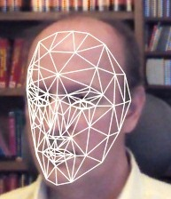 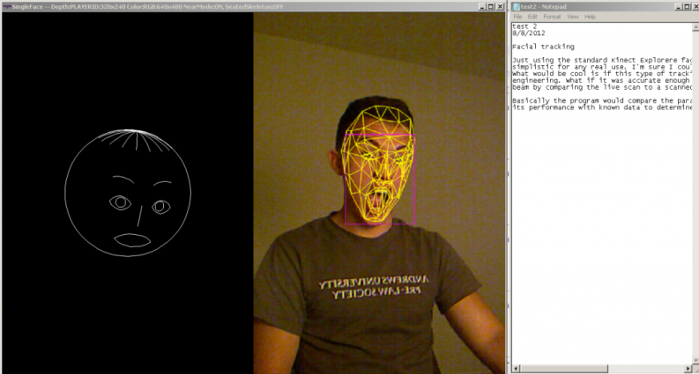

Figure Kinect Face Tracking

2.3 AcceleGlove

Acceleglove is an input device which captures and produces hand and finger position and motion data.

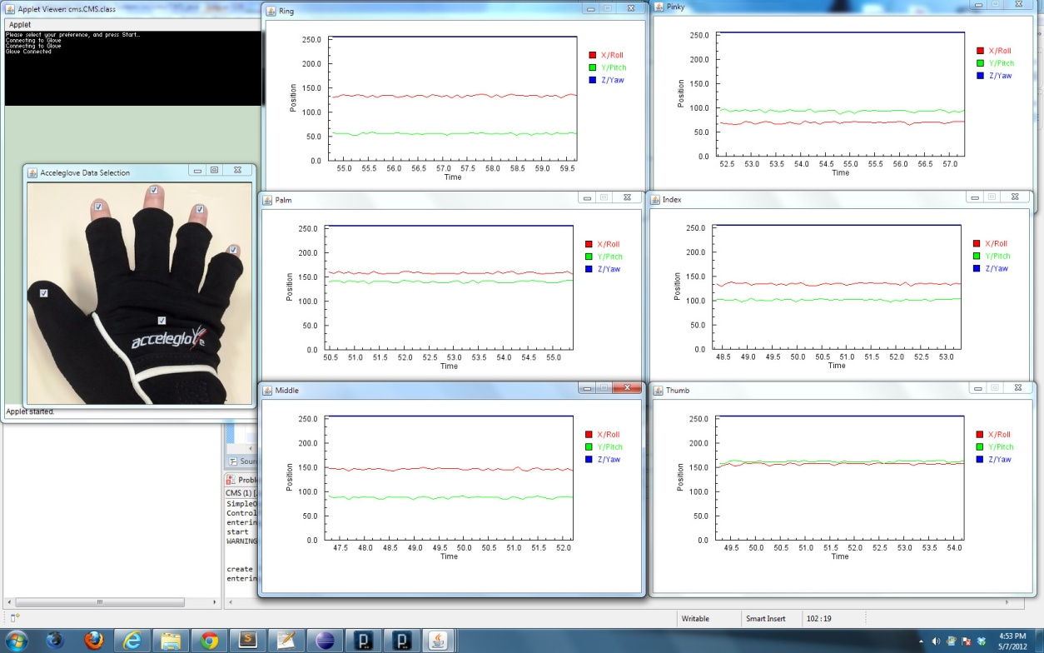

Figure Finger position from AcceleGlove

Similar to Leap Motion, the SDK provided is based on Java, greatly reducing hassles of integrating another sensor into the system. Instruction to install and setup the SDK is provided in the user guide (AnthroTronix)

2.4 Existing physiotherapy application

YouGrabber

YouGrabber developed by Swiss startup YouRehab consists of a pair of therapy-optimized data gloves with integrated movement tracking, providing interactive therapy exercises which focus on visuo-motor finger, hand and arm coordination. This enables training for bimanual reaching and grabbing (YouRehab)

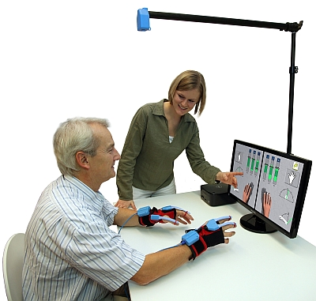

Figure YouGrabber

However as can be seen from Figure 4, with YouGrabber patients go through hassles of wearing data gloves, which severely injured might not even able to do so. Besides YouGrabber, most of hand rehab applications from my research involve wearing sensors, not meeting the needs for simple and hassle-free yet accurate hand rehab application.

Chapter 3. Proposed Solution

3.1 iFarm

This project therefore proposes a solution tilted as iFarm, an acronym for a Multimodal Assistive Finger Rehab System. iFarm aims to provide a user-friendly home-based physiotherapy application where there is no need for patients to wear hand tracking sensors.

3.2 Overview and Objective of iFarm

The objective of this project is to design a multimodal sensors-controlled biofeedback wristband for hand rehab exercise with 3D visualization.

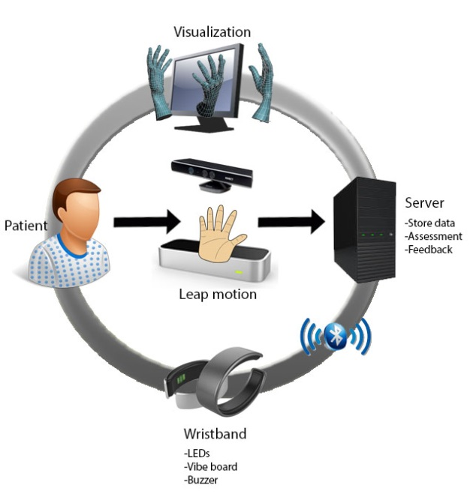

Figure Overview of iFarm

Chapter 4. iFarm Design and Integration

4.1 Application flow

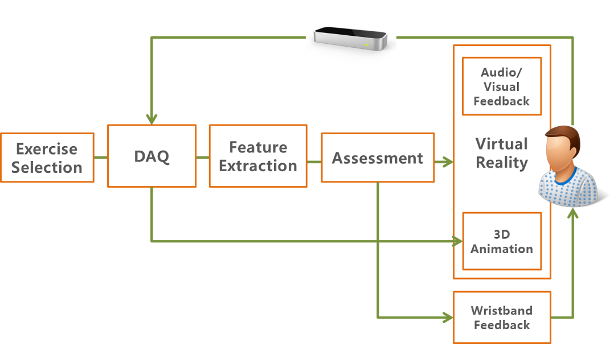

Figure Application flow of iFarm

Once exercise is selected and patient is ready to start exercise, user’s hand tracking information will be collected at DAQ unit from Leap Motion, which will be soon processed by Feature Extraction unit where necessary data features are selected and passed over to the next unit. Assessment unit will then identify whether the exercise is done correctly or not and how many repetitions user has done, notifying 3D Unity and the Arduino IDE its exercise progress. At last, respective visual, audio and even haptic feedback message will be sent through the 3D unity UI and the Arduino-controlled wristband.

4.2 System architecture

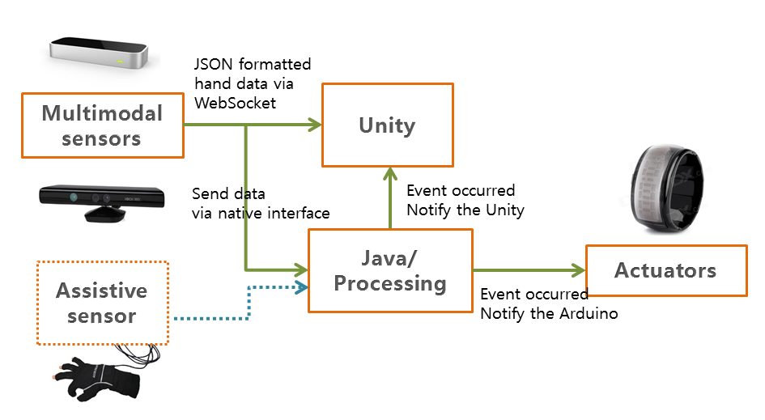

Figure System Architecture

Leap motion controller provides tracking data not only by its native interface but also through a WebSocket server. The WebSocket server listens to port 6347 on the localhost domain ([http://127.0.0.1:6437](https://developer.leapmotion.com/documentation/skeletal/java/_static/JSONViewer.html)). Any client application, including Web clients that can make a WebSocket connection can access the Leap Motion tracking data in the form of JSON-formatted messages (Leap motion team). In this project, Unity will directly access the Leap motion to obtain hand data for 3D visualization.

At the same time, Leap Motion also feeds Java with its raw tracking data. DAQ, Feature Extraction and Assessment units running on Java platform will then process such data to notify both Unity and Arduino IDE for respective biofeedback.

4.3 Program flow

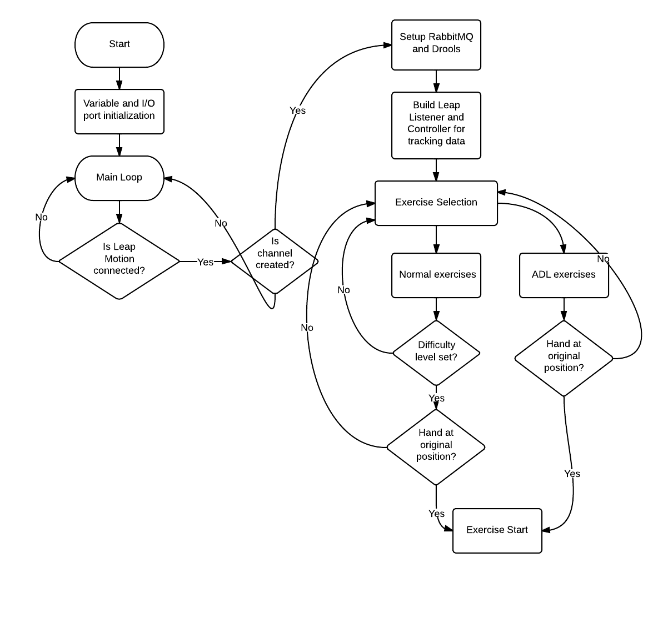

Figure Program flow

4.4 Java-Unity integration

For Java to notify Unity (C#) for every event occurred, a middleware which is able to connect each application as components of a larger application is required.

**RabbitMQ** is a message-oriented middleware implementing the Advanced Message Queuing Protocol which enables messaging across different platforms (Pivotal). RabbitMQ is therefore chosen for the integration.

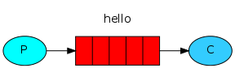

Figure RabbitMQ

Once RabbitMQ is installed and libraries are imported (<http://www.rabbitmq.com/download.html>), it can accept and forward messages to the client.

**Producer (P)** here is Java, where strings of message are passed over to the queue whenever conditions are met.

In java, **a queue** is created which lives inside RabbitMQ. A queue is not bound by any limits, it can store as many messages as you wish functioning like an infinite buffer. Many producers can send messages that go to one queue, many consumers can try to receive data from one queue. However in this project, a simple one-to-one case is only considered.

**Consumer (C)** in this case is the Unity which waits to receive messages.

Chapter 6. Approach to finger movement assessment

6.1 Data Analysis

For analysis and evaluation purpose, hand tracking data is stored in real time in CSV file format. To better identify how tracking data is changed while each rehab exercise is carried out, graphs are plotted based on the CSV data obtained.

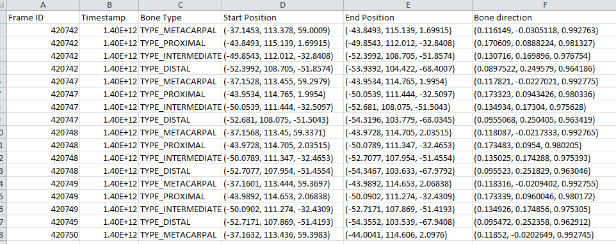

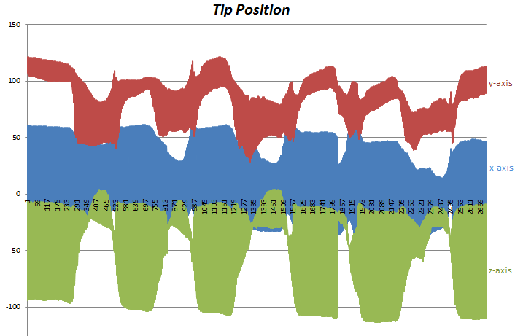

Figure Data analysis

This visually helps the author identifying which data most explicitly signifies the successful carry out of each exercise. Furthermore this provides the fundamental knowledge required for developing data assessment unit. For instance, the author could identify and fine-tune the conditions for starting position of hand (original), which is

1. Grab and pinch strength = 0

2. 0.8< |value of palm’s z direction and y normal vector|<1.1

6.2 Types of Exercise

**- Activities of Daily Living (ADL)**

An individual's ability to perform ADLs is important for determining what type of long-term care (e.g. nursing-home care or home care) and coverage the individual needs (i.e. Medicare, Medicaid or long-term care insurance) (Activities of daily living). One of the key advantages iFarm has over other rehab applications is that it offers fun and complex daily activities such as cooking and brushing teeth as its ADL exercises. This provides therapists more concrete data to assess patient’s progress of hand recovery. ADL exercise will be visually simulated by 3D Unity, making physiotherapy routine more fun and practical.

**- Traditional hand rehab exercises**

Besides ADL exercises, iFarm also provides traditional grabbing, stretching and pinching exercises.

6.3 Difficulty level

Difficulty level for each exercise can be set from Beginner to Intermediate to Advanced. This is based on simple algorithm of calculating relevant fingertip speed and hence setting different speed limit for each difficulty level. If advanced is selected, higher minimum speed limit is set and hence one should carry out exercise above this speed.

Chapter 7. Discussion

7.1 Summary of tasks done

Below is the summary of what had been done for the past 10 week:

- Data acquisition: Hand motion tracking information from Leap Motion, Voice recognition and face tracking information from Kinect, additional hand information from AcceleGlove

- Data storage: Finger tracking data stored in .CSV for each time frame for evaluation and analysis purpose

- Feature Extraction: Meaningful tracking information is selected and passed to the assessment unit

- Exercise assessment: Conditions for each exercise are identified and tested

- Feedback: Once notified, respective action is triggered on

1. Simple GUI (for evaluation purpose)

2. Unity 3D

3. Arduino-wristband

7.2 Future tasks to be done

The development of iFarm application is still in progress. To complete the working prototype for coming Tan Kah Kee Young Inventor’s Award, tasks below must be done.

- Kinect integration for more complete NUI and precise data collection: As shown in **2.2 Kinect** under Literature Review, research supports that speech recognition and face tracking can be easily incorporated with Unity 3D as both the Unity 3D and MS Kinect SDK are based on C# platform.

- 3D visualization of hand and user interface by Unity 3D

- Assessment for more rehab exercises

- Bluetooth communication between the Arduino and the host.

- Design of wristband

- Replace Assessment unit with Drools rule engine, if possible

- Accelerometer on the wristband for extra motion information (optional)

* 1. Problems encountered

There was initial attempt to use Drools (Rule Engine) as an assessment unit for iFarm, where Java constantly feeds Drools with meaningful features such as tip velocity, for each time frame.

Since Drools can be written in simple if-then statement, it is easy to understand and amend the assessment criteria and rules if required in the future. This makes iFarm more business-friendly and scalable.

However, it was later found out that Leap motion sends up to 300 frames of tracking data per second and Drools is not designed to handle such constant stream of data. Due to time constraint, assessment is done within Java instead.

Chapter 8. Conclusion

This project explored the capabilities of Multimodal Sensors-Arduino application in home-based physiotherapy industry. The author carried out detailed discussion and analysis on hand gesture interface in particular, to study how such invisible controller could be effectively implemented on physiotherapy rehabilitation application such as iFarm.

During the initial stage of development, extensive research was done on similar biofeedback applications to give the author ideas how iFarm would be designed. Variety of hand tracking features such as speed and position of bones were studied to deepen my understanding of Leap Motion.

At the same time, the author familiarized herself with the Kinect, exploring numerous libraries, its speech and facing tracking capabilities and its applicability to iFarm, especially with its integration with the 3D Unity UI. Data acquisition, storage and analysis had been successfully done to aid development of accurate and more complete data assessment unit which is the most important and crucial part of iFarm intelligence.

3D unity is chosen as the main UI for iFarm, to provide dynamic and robust user experience. Subsequently it was necessary to use appropriate message protocol, RabbitMQ, to enable communication between Java and Unity.

Lilypad Arduino, a microcontroller board designed for wearable is used with other actuators like RGB LED, vibe board and buzzer to design a simple prototype of biofeedback wristband. RXTX library is used for communication between Java and the Arduino IDE.

To summarize, the iFarm project explores the potential capabilities of hand tracking interface in physiotherapy industry, opening up numerous possibilities for future implementations and studies when integrating with other sensors and platforms.

# **Bibliography**

*Activities of daily living.* (n.d.). Retrieved from Wikipedia: http://en.wikipedia.org/wiki/Activities_of_daily_living

AnthroTronix. (n.d.). *About AcceleGlove.* Retrieved from http://www.anthrotronix.com/index.php?option=com_content&view=article&id=46&Itemid=162

Beswick AD, R. K.-H. (2008). Complex interventions to improve physical function and maintain independent living in elderly people: a systematic review and meta-analysis.

Leap Developer Community. (2014). *Leap Documentation.* Retrieved July 23, 2014, from Leap Developer Portal: https://developer.leapmotion.com/documentation/skeletal/csharp/devguide/Leap_Guides.html?proglang=current

Leap motion team. (n.d.). *Developer portal.* Retrieved from Leap motion: https://developer.leapmotion.com/

Microsoft Kinect. (n.d.). *Kinect for Windows-Develop.* Retrieved from http://www.microsoft.com/en-us/kinectforwindows/develop/

*NUI: Natural User Interface.* (n.d.). Retrieved from Microsoft Research: http://research.microsoft.com/en-us/collaboration/focus/nui/

Pivotal. (n.d.). *Documentation.* Retrieved from RabbitMQ - Messaging that just works: http://www.rabbitmq.com/

Washio, T. S. (2012). *kinect-mssdk-openni-bridge.* Retrieved from google code: https://code.google.com/p/kinect-mssdk-openni-bridge/

YouRehab. (n.d.). *YouGrabber.* Retrieved from http://yourehab.com/yougrabber/